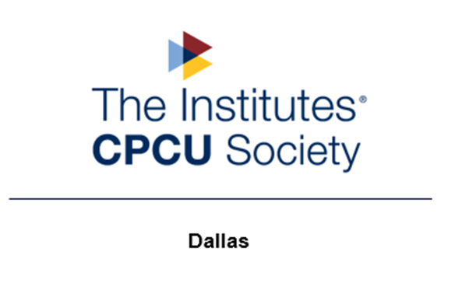

The Dallas Chapter of the CPCU Society is excited to host our 2022 Hybrid I-Day on Thursday, August 25, 2022. This event will bring together industry professionals for a day filled with relevant and educational programming, including popular topics on emerging risks, DE&I and professional development.
Our organization is dedicated to promoting education. The proceeds will support the event and sponsorships for industry professionals and Insurance and Risk Management students at University of Texas at Dallas (UTD) and University of North Texas (UNT).
By sponsoring the 2022 Dallas Chapter Virtual I-Day, you can demonstrate your commitment to the CPCU Society and its members. In return for your valuable support as a sponsor, your company will gain visibility and recognition. The Dallas Chapter is hopeful that we can count on your financial support!
Please confirm which Sponsorship level your company is interested from the following options:
Sponsorship Levels:
- Raffle Sponsor – Provide a branded giveaway item or e-gift card valued at $25
- Influencer Sponsor ($250) - Your company logo will be included in our event program and a provided video clip, up to 2 minutes will be played during the program.
- Trendsetter Sponsor ($500) – Influencer Sponsor benefits, 2 I-Day tickets, and a promotional speaking opportunity at the end of the event
- Thought Leader Sponsor ($1,000) – Trendsetter Sponsor benefits, 4 I-Day tickets
- Title Sponsor (2,500) – Thought Leader Sponsor benefits, sponsorship table (8 tickets) and visibility as the event’s Title Sponsor
Mail your sponsorship check to our Chapter Treasurer. It must be received by August 10, 2022:
Attn: Ksenia Wilder 10455 N Central Expressway, Suite 109, Box 351 Dallas, TX 75231
If payment by credit card is preferred, please email Ksenia.Wilder@libertymutual.com for arrangements to pay via Zelle or PayPal.
Thank you in advance for your support of the CPCU Society Dallas Chapter!

Sincerely,
Precious Norman Walton, CPCU, SHRM-CP, TRIP, AIC, AIS, AINS, ACS
Dallas Chapter Past President and I-Day Committee Chair

